**AERO-FLIGHT SCHEDULING AND RESERVING SYSTEM**

**BY**

**SAMUEL ATTAS LAAH**

**191212047**

**A PROJECT SUBMITTED TO THE DEPARTMENT OF SOFTWARE ENGINEERING,, FACULTY OF COMPUTING, NILE UNIVERSITY OF NIGERIA, IN PARTIAL FULFILMENT OF THE REQUIREMENTS FOR THE AWARD OF DEGREE OF BACHELOR OF SCIENCE IN SOFTWARE ENGINEERING |INFORMATION TECHNOLOGY, NILE UNIVERSITY OF NIGERIA**

**JUNE 2024**

**NILE UNIVERSITY OF NIGERIA**

**STATUS CONFIRMATION FOR BACHELOR’S PROJECT**

**AERO-FLIGHT SCHEDULING AND RESERVING SYSTEM**

**ACADEMIC SESSION : 2023/2024**

I, **SAMUEL** ATTAS LAAH Agree to allow this Degree’s Project to be kept at the Library under the following terms:

1. This Degree Project is the property of Nile University of Nigeria.
2. The library has the right to make copies for educational purposes only.
3. The library is allowed to make copies of this report for educational exchange between higher educational institutions.
4. ** Please Mark (√)



|  |  |  |
| --- | --- | --- |
| k | CONFIDENTIAL | (Contains information of high security or of great importance to Nigeria as STIPULATED under the OFFICIAL SECRET ACT ) |
| k | RESTRICTED | (Contains restricted information as determined by the Organization/institution where research was conducted) |
| Text BoxShapel | FREE ACCESS |  |

|  |  |  |  |  |  |
| --- | --- | --- | --- | --- | --- |
| _________________________ |  | Approved by,      __________________________ |  |  |  |
| (WRITER’S SIGNATURE) |  | (SUPERVISOR’S SIGNATURE) |  |  |  |
| Permanent Address :  22 shettima laah street  Kunle suleiman.close LIFE CAMP ABUJA  Text Box  Date: ___________________ |  | Supervisor’s name:  Mr Austin Ogar |  |  |  |

CERTIFICATION

This is to certify that, the project titled “AN AERO-FLIGHT SCHEDULING AND RESERVING SYSTEM ” by SAMUEL ATTAS LAAH 191212047 has been approved by the undersigned for meeting the requirements for the award of Bachelor of Science in Software Engineering | Information Technology (BSc. Hons in Software Engineering | Information Technology by the department of Software Engineering and Information Technology, Nile University of Nigeria, Abuja.

__________________________

Mr Austin Ogar

PROJECT SUPERVISOR

__________________________

Dr. Ibrahim Salihu Anka

H.O.D SOFTWARE ENGINEERING AND INFORMATION TECHNOLOGY

__________________________

Prof. Musa Muhammad

DEAN (FCOM)

__________________________

EXTERNAL SUPERVISOR

DESIGN AND IMPLEMENTATION OF AN AERO-FLIGHT SCHEDULING AND RESERVING SYSTEM (A CASE STUDY OF ‘AIR PEACE’)

SAMUEL ATTAS LAAH

191212047

A project submitted in

partial fulfillment of the requirement for the award of the

Degree of Bachelor of Science (B.Sc.) in Software Engineering | Information Technology

Faculty of COMPUTING, Department of Software Engineering and Information Technology

JUNE, 2024

**DECLARATION**

I hereby declare that this project title ‘AERO- FLIGHT SCHEDULING AND RESERVING SYSTEM is the result of my own work under the supervision of Mr Austin Ogar and has not been and will not be presented elsewhere for the award of any degree. I further declare that all sources have been acknowledged appropriately in the reference section

Student : …………………………………………………….

Date : …………………………………………………….

Supervisor : …………………………………………………….

Mr Austin Ogar

DEDICATION

I dedicate this project to Almighty God, my strong pillar, my source of inspiration, wisdom, the source of all knowledge, and my great comforter. He granted me the willpower and the gift of life, in his unending kindness, so that I may successfully complete this task. I also thank my parents for their unwavering support, prayers, and encouragement in helping me finish my project.

ACKNOWLEDGEMENT

I want to express my profound gratitude to my creator, Almighty God, who has sustained me and has been my great provider throughout my stay in Nile University. I also want to thank all those who have helped and supported me in one way or the other towards my academic journey and the journey of life.

My special thanks go out to my lovely parents, who have prayed, supported and encouraged me all the way in my efforts. To my siblings and other relatives, thank you all for the support.

A special thanks go to my able supervisor Mr Austin ogar ,, for the support and time put into my project to ensure excellence and also for the knowledge and encouragement.

Lastly, I want to thank my friends, course mates, lecturers, and the Department of Software Engineering.

ABSTRACT

*Technology and science are taking over the world. Every phase of contemporary business operations makes heavy use of web applications. In order to enhance the booking process for Nigeria Air, research was conducted to develop and deploy an online airline reservation system. Users can browse flight schedules, register their information when signing in or get to the bookings information page, purchase and cancel a ticket using the computerized system.*

*This initiative is primarily for Nigerian travelers. Using this system, Nigeria Air can keep track of its data and also make the booking process easier and cheaper for passengers. This is a web application with a database system proposed to Nigeria Air for simplifying and reducing costs for their booking operations. This project will be built with JavaScript on React for the Frontend and Firebase for the database.*

**TABLE OF CONTENT**

CERTIFICATION………………………………………………….…………………...…...II

DECLARATION……………………………………………….…………………………..IV

DEDICATION…………………………………………………….…….…………………..V

ACKNOWLEDGMENT………………………………………….……………..………....VI

ABSTRACT.........................................................................................................................VII

TABLE OF CONTENTS…………………………………………..………….…………VIII

LIST OF FIGURES……………………………………………………………...………....X

LIST OF TABLES…………………………………………………………………………XI

**CHAPTER ONE**...................................................................................................................1

**INTRODUCTION**……………………………………………...…….……………1

1.1 BACKGROUND OF THE STUDY .......................................................1

1.2 STATEMENT OF THE PROBLEM.......................................................3

1.3 SIGNIFICANCE OF THE STUDY………………………………….....4

1.4 AIM AND OBJECTIVES........................................................................4

1.5 SCOPE AND LIMITATION OF THE STUDY……………….……….4

1.6 ORGANIZATION OF STUDY…………………………………...……5

1.7 DEFINITION OF OPERATIONAL TERMS…………………………..6

**CHAPTER TWO .................................................................................................................**7

**LITERATURE REVIEW .......................................................................................7**

2.1 GENERAL INFORMATION**…………………………………..….……7**

2.2 RELATED WORKS………………………………….………………....9

2.3 SUMMARY OF THE REVIEW …………………………………...….14

**CHAPTER THREE .............................................................................................................**17

**SYSTEM ANALYSIS AND DESIGN …………………………………………....**17

3.1 SYSTEM ANALYSIS**…………………………………...………….......**17

3.1.1 ANALYSIS OF THE EXISTING SYSTEM**........................….**17

3.1.2 LIMITATION OF THE EXISTING SYSTEM .......................18

3.1.3 JUSTIFICATION FOR THE NEW SYSTEM ….……………18

3.1.4 DESCRIPTION OF THE NEW SYSTEM……………………19

3.2 DESIGN OF THE PROPOSED SYSTEM…………………...…19

3.2.1 DATA MODEL……………………………………………….20

3.2.2 FUNCTIONAL REQUIREMNT…………………………...…22

3.2.3 SYSTEM ARCHITECTURE……………………………...….25

3.2.4 SOFTWARE STRUCTURE………………………………….26

3.2.5 WORKFLOW OF USE CASES………………………………27

**CHAPTER FOUR**……………………………………………………………………....….29

**IMPLEMENTATION AND DISCUSSION**………………………………...……29

4.1 SYSTEM REQUIREMENT FOR DEVELOPMENT…………………..29

4.2 SYSTEM MENUS IMPLEMENTATION …………………………….29

4.3 DATABASE IMPLEMENTATION…………………………………....40

4.4 SYSTEM TESTING…………………………………………………….42

**CHAPTER 5**………………………………………………………………………...……...44

**CONCLUSION AND RECOMMENDATION**…………………………..…….. .44

5.1 SUMMARY OF THE STUDY…………………………………………44

5.2 CONCLUSION AND RECOMMENDATION…………..…………….44

REFERENCE…………………………………………………………….………………….47

**APPENDICES** ..................................................................................................................... 49

**LIST OF FIGURES**

Figure 3.1: ER Schema…………………………………………………………...………21

Figure 3.2: Use case Diagram…………………………………………………...……….23

Figure 3.3: Customer Use Case Diagram……………………………………...………...24

Figure 3.4: Administrator Use Case Diagram………………………………...…………24

Figure 3.5: Deployment Diagram……………………………...……………………...…25

Figure 3.6: Class Diagram……………………………………………………………….26

Figure 3.7: Activity Diagram…………………………………………………………….27

Figure 4.1: Home page…………………………………………………..………………30

Figure 4.2: About us page…………………………………..…………………..……….31

Figure 4.3: Sign up page…………………………………..…………………………….32

Figure 4.4: Sign up page with details inputted………...………………………………..32

Figure 4.5: Sign in page…………………………………………………………………33

Figure 4.6: Payment page………………………………………...……………………..34

Figure 4.7: Book a Flight form for Round Trip…………………………………………35

Figure 4.8: Book a Flight form for one-way Trip…………………….…………………35

Figure 4.9: Ticket pass print……………………………………….……………………36

Figure 4.10: Contact Us page…………………………………...………………………37

Figure 4.11: Admin Home interface………………………...…………………………..38

Figure 4.12: Admin Create Flight interface……………………………………………..39

Figure 4.13: Firebase Configuration…………………………………………………….40

Figure 4.14: Firebase Backend (Authentication)…….………………………………….41

Figure 4.15: Firebase Backend (Database)………...……………………………………41

**LIST OF TABLES**

Table 2.1: Brief summary of review………………………………………………………14

Table 4.1: Test Run through on system……………………………………………..…….42

Table 4.2: The result of the Tests…………………………………………………………43

**CHAPTER 1**

**INTRODUCTION**

*This chapter introduces the project. The background of the whole study is statement, the reason for the project is given and the aims and objectives are stated which guide the project.*

* 1. **Background of Study**

The world as we know it is entering an era of mass globalization, as more people are getting increasingly aware of cutting edge technology that improves the simplicity of carrying out daily tasks massively. Peoples increasing reliance on technology in this lifetime is demonstrated by developments in the fields of education, health, communications, transportation, and other fields. People can now conduct business more easily thanks to the Internet.

Air Peace was founded in 2013 by Nigerian lawyer and businessman Allen Onyema with the goal of using it as a vehicle to give young people in Nigeria access to the economy.The airline started out using Dornier 328s and Boeing 737s. In 2017, the airline launched its first international route to Kotoka International Airport in Accra, Ghana.By 2018, Air Peace held the largest market share in Nigeria's domestic airline market.In the same year, the airline received its first Boeing 777s.That year, the airline started operating flights to Sharjah.

In 2020, Air Peace began flying to Johannesburg, South Africa.The previous carrier airline, Nigeria Airways, was mired in controversy which led to the airline going into bankruptcy due to corruption and continual financial mismanagement. The airline and unions are still conflicted over unpaid reimbursements to former workers. The primary goal of the Aero-Flight Scheduling and Assignment System (AFSAS) is to make the complicated process of purchasing airline tickets easier by making it available online in a user-friendly setting. By allowing consumers to book flights as they see fit, it also seeks to improve efficiency and lessen the drawbacks of Nigerian Air's manual flight booking procedure.

Users of the system can look up flights between two places on a specific day, select a flight based on its details, book flights, and cancel reservations.

The procedure lets the airline passenger to search for flights that are available between the two travel destinations, referred to as the "Departure city" and "Arrival city," for certain departure and arrival dates.

The system shows every important information on the flight, including the flight number, name, cost, length, etc. Following a search, the system presents a listing of current flights and allows the user to select a particular trip. The software then verifies if there are any seats available on the flight. If seats are available, the traveler is permitted to make reservation. If not, the consumer is should reschedule. The system requests the user's information, including address, name, email, and password, in order to book a flight. After the validity check, reservation is made, and the user and airline databases are updated. The system also enables customers to cancel reservations in the event of a problem.

A project to motivate the basic ideas of a system used for reserving tickets is the web-based Flight Reservation project. AFS helps you organize your bookings, prices, timetables, and customer data systematically and effectively. Today's flight booking system has emerged into the Computer Reservation System . American Airlines introduced the first automatic scheduling system in 1946, called the Electromechanical Reservoir. A new machine called the Magnetronic Reservoir followed. In 1959, an improved automated reservation system called SABER was introduced to strengthen existing reservoirs (Winston, 1995). Similarly, other airlines have developed their ticket booking and management systems. Today, many brands are working with airlines worldwide to provide user-friendly direct flight systems, increasing productivity and efficiency. Today's leading ARS brands include Abacus, Amadeus, Navitaire, Saber, and TravelSky.

AFSAS is powered by a well-designed database management system (DBMS) in which flight information is integrated. A user-friendly UI is also provided so that searches performed by the user return the correct results by accessing the information stored in the database.

For the analysis of the system, input analysis will consist of the processes used to feed in data like how many passengers will be traveling, Passenger details, and Payment details. Process analysis will collect the inputs and process them properly for effective use which will be kept in the database for future use. The resulting documentation produced after processing system-supplied data, that includes the traveler details or Payment details, will be displayed in the output analysis.

For the flight reservation system, there are two different types of users. Customers and administrators are the first and second, respectively. Customers can use the program with no prior knowledge or training. But they would find instructions for making a hotel and ticket reservation on the airline's website. To use the application, the administrators would need to receive training.

**1.2 Statement of the Problem**

The flight booking system is aimed at booking and reserving flights for people. During the course of my research, it was found that Nigeria Air would use travel agencies that provide fundamental functions, such as flight searching, flight selection, and ticket payment, but lacked a personal website.

Making reservations through travel agencies increases the total amount payable by the intending passenger since the passenger is supposed to pay a commission rate of 8 to 10 percent of the travel tickets purchased through the travel agent. Due to this discovery,

the concept of developing a system that both enhances the features already provided by travel agencies and gives additional features in the form of a website is needed. Passengers cannot print their boarding passes using the current system. These shortcomings make AFSAS necessary.

**1.3 Significance of Study**

The significance of flight reservation systems lies in the computerization of airline activities. It facilitates day-to-day operations of Nigeria Air and helps reduce errors that can occur when using a second-party booking system. If passengers can pick their respective positions and generate their tickets directly from the reservation system, it will load faster so there will not be a line at the ticket counter.

 Organizational profitability is positively impacted by the personalization of operations. The study's findings also help managers make the most use of available aircraft capacity and aid airlines by streamlining the reservation process without involving physical employees, which will improve performance in the fiercely competitive market and ensure the smooth operation of their daily operations.

**1.4 Aim and Objectives**

This project aim at the development and design of a web-based flight reservation system that would automate airline operations and allow passengers of Nigeria Air to easily book flights through an effective yet simple user interface.

The objectives include:

1. To design an online interface used for reservation and ticket booking for Nigeria Air.
2. To implement a working flight reservation system that books tickets.
3. To test and evaluate the system.

**1.5 Scope of the Study**

The goal of this project is to develop an online system that will enable potential Nigeria Air customers look up flights according to the given dates, book seats, make payments for flights, generate tickets, and cancel flights. Prices of the available flights would show, payments would also be made for the booking, and reservations would be made. This can also be modified and canceled if need be.

**1.6 Organization of Study**

**Chapter 1**: The proposed system is introduced in this chapter. First, there was the background investigation, which covered the development of airline reservation systems as well as a quick summary of Nigeria Air. After that is the problem statement, where I gave a few problems that is faced in the current system used by Nigeria Air. Aims and objectives are stated as what I would accomplish at the end for the system. The significance and scope of study are stated. This chapter provides an overview of what the project is about.

**Chapter 2**:This is the literature review chapter where much research is made about the proposed system. First is the introduction where various airlines and computerized information system are talked about. Next are the literatures I reviewed in order to understand how reservation systems work.

**Chapter 3**: The constraints and explanation of the new system are the main topics of this section's analysis of the proposed system. It is described how the ER Diagram, class diagram, activity diagram, deployment diagram, and use case diagram will be utilized to create and implement the system.

**Chapter** 4: This section uses the diagrams as a help in implementing the proposed work and turning it into a whole system that is functional. You also talk about the front and back end of the system.

**Chapter** 5: This is where the conclusions of the whole work is done, and recommendations are made of how the system can be sustained or improved.

**1.7 Definitions of Operational Terms**

**Flight Reservation System (FRS)** -- This is an online application program that is used to save, retrieve, and complete transactions involving travel by air.

**Database Management System (DBMS)** -- This data set is arranged such that a computer program may easily choose the particular bits of information it needs.

**User Interface (UI)** -- the ways in which a customer and a computer system communicate, in particular the utilization of input devices and software.

**Airline Reservation System (ARS)** -- mechanisms that let airlines sell the tickets in their inventory.

**Computer Reservation System (CRS)** -- Utilizing this automated system, data can be stored and recovered, as well as to carry out transactions relating to travels. It was first developed and used by airlines before being expanded for usage by travel companies.

**Global Distribution System (GDS) --** A company operates a system that permits automated transfers connecting external providers and travel agents in order to provide customers with services linked to travel.

**Reservation** -- a formal confirmation or warranty of a contract that secures services in advance.

**CHAPTER 2**

**LITERATURE REVIEW**

*This is the literature review chapter where much research is made about the proposed system, where you can see the problems and strengths of related projects and also find out technologies and techniques used.*

1. **General Information**

American Airlines unveiled the first computerized reservations system in 1946. Other airlines from around the world have shown an interest the automated systems to follow data and boost proficiency because it is a very alluring aim for the sector. Over time, this method has been evolved and altered. Later, when other airlines made further investments in R&D to commercialize new systems, the airline created its system later around the late 1960s and early 1970s.

The flight booking system was one of the first things that was enhanced to boost efficiency. Nigeria Air is a proposed airline in Nigeria with Ethiopian Airlines as the core investor and technical partner of the new national carrier. The computer reservation system, or "CRS," was eventually derived from the airline reservation system. The computer reservation system connects to the Global Distribution System, or "GDS," and is used to make reservations with particular airlines. The Passenger Service System (PSS), a program that enters into direct contracts with passengers, includes the Flight Reservation System. (Crosby, 2015).

Steven Alter defines information systems as the processes which employ technological innovations to save, send, retrieve, update, and present information required in one or more business operations in his book, "Information Systems 2nd Edition." In his book "Information Systems," James A. O'Brien defines information systems as "any arranged combination of individuals, technology, software, computer networks, and data resources which gather, evolve, and split information within an organization."

Businesses can thrive through initiatives like increased networking and cost-cutting techniques.

The usage of information systems is necessary as the world moves toward a knowledge- or information-based society, which is the basis for conducting business today. While signing up, a huge amount of information about applicants is required, such as their data, so therefore a system that enables automated ways to maintain such data, data collecting is necessary. (Laudon J.P and Laudon K, 2006).

Customer satisfaction is more flexible now that businesses using information systems are aware of the necessity to keep customers; therefore they concentrate on them to make sure they are happy with the services.

The only device utilized to store, process, and retrieve data is a computer; (Masaba, 2000). It stores information utilizing a database and organizes the these data for a simple and rapid access at the time it is needed.

(Ibid, 2000) writes about the advantages of Computerized system;

* Since there is less duplication, the system provides reliable information.
* Data retrieval and access is simple.
* Individual traveler records can be evaluated.

(Ibid, 2000) writes about the disadvantages of Computerized system;

* To access and take any actions on data saved computers, you must have a basic understanding of computers.
* When a computer system malfunctions, there won't be any business transactions if there isn't a bypass method.

Therefore, it is clear that adopting a computerized system has more advantages than disadvantages, for which there are now several alternatives.

1. **Related Works**

Around the middle of the 1950s, for tasks like seat allocation, servicing planning, and plane loading, airlines started using basic internal systems. Modern reservation systems are comprehensive, from the time of the initial reservation until the end, complex systems manage a range of flight operations and meet client demands. A computerized system called a computer reservations system (CRS) is used to store, retrieve, and finalize transactions relating to air travel. (Johanson, 2014). CRSs were first created and run by airlines, but gradually became used by travel firms. Global distribution systems are significant CRS businesses that purchase and resell airline tickets (GDS). Airlines have sold the majority of their direct ownership to specialized GDS businesses, who provide consumers with access to their systems via Internet gateways. Bookings for lodging, car rentals, and flights are frequently available through modern GDSs (GazetteLive, 2011). Although these are typically not incorporated with the main system, they also offer accessibility to train bookings in certain areas.

On a flight from Los Angeles to New York in 1953, C. R. Smith, the CEO of American Airlines, was seated next to R. Blair Smith, a sales representative for IBM. C.R. invited Blair to visit to examine how IBM could enhance his Reservoir system. A couple of low-level research commenced when Blair informed Thomas Watson, Jr. that Americans were eager to collaborate more. This led to the initiation of a project known as the Semi-Automated Business Research Environment (SABRE) in 1959. (Johanson, 2014). The global network was the largest personal information processing system in the globe when it was completed in December 1964. Prior to deregulation, travel agencies joined the airline reservation systems.

There are three major GDS suppliers as of February 2009: Amadeus, Shares, Travelport (which combines the systems of Worldspan and Galileo), and Sabre. One significant regional GDS, Abacus, serves the Asian market, and several other regional players, such as Infini and Axxess (both serving Japan), Travelsky (China) and Topas (South Korea), serve specific nations. There is a secondary GDS called Navitaire that hosts "ticketless" airlines such as AirTran, and previously JetBlue (Atkinson, 2015).

Some airlines utilize their own proprietary GDS editions in conjunction to these "standardized" GDSs to manage their business operations. Examples of such system are EDS SHARES and Deltamatic, which are both based on the Worldspan platform. With well over 100 airlines managing inventory, SITA Reservations continues to be the biggest neutral multi-host flight booking system.

The flights with open seats are recorded in an airline's directory. Frequently, operational classes (such First, Business, or Economy class) and about 26 other classes are used to categorize an airline's inventory, each of which has a particular price range and set of booking requirements (Bilotkack, 2011). With standardized interfaces and a schedule distribution system, inventory data is imported and managed. The systems used by other airlines were shortly created. The Delta Automatic Travel Account System (DATAS) was introduced by Delta Air Lines in 1968.

United Airlines and Trans World According to (Wikipedia, 2012), The Apollo Reservation System and Programmed Airline Reservation System (PARS), accordingly, came after airlines in 1971. Requests from travel agencies for anything that would streamline their part of the booking processes and enable them to book flights directly via the various airline reservation systems started to pour in swiftly. Concerned that this would give agents enormous authority, to serve as a single hub for traveling to the US, American Airlines CEO Robert Crandall suggested establishing a sector-wide computer reservation system. Other airlines declined it, citing problems with the regulatory plan.

Global Distribution Systems (GDS), a global automated reservation system, is utilized by travel agencies, online booking services, and large businesses as a single point of accessible for making reservations for flights, lodging, vehicle rentals, and other travel-related things. Amadeus, Galileo, Sabre, and WorldSpan are the leading global distribution systems. Important airlines, car rental companies, and hotels jointly own and run them.(Global, 2012).

As soon as a new technology is developed, such as portable technology, various applications for reservation administrations can be developed to improve and simplify people's life. The suggested method is designed to overcome manual system problems by allowing reservations to be made remotely from home or another location, saving both time and effort enhancing the process of making a flight reservation. also discusses the Mobile Airline Reservation System (MARS) in order to look into seat reservation practices in the Nigerian aviation industry and the benefits of mobile applications. (Prajapati et al., 2018).

(Xiao, 2002), an in-flight computer system that connects directly to a central booking system, or a terminal in a travel agent's office, is referred to as a flight reservation system. Travel agencies may provide their customers instant internet access to the majority of available plane seats to anywhere around the world by establishing satellite linkages into ground-based computer bookings systems that allow you order or modify tickets from your comfort place. A flight reservation system, according to the researchers, is an automated system that was originally developed and used by airlines to store data, retrieve data from, and conduct operations related to air travel. These platforms were eventually developed so that travel agencies could utilize it, especially to purchase or sell airline tickets and make the systems available to clients via gateways on the Internet.

(Onome Amawhe, 2017), One of the biggest one-stop travel shops in Africa, Wakanow, operates a website where clients can manage their reservations. The first online travel agency in Nigeria, Wakanow, was founded in 2008 with the goal of bridging the gap and removing the obstacles and inefficiencies the country's travel industry was experiencing. Before starting their operations in 2008, the sector comprised of booking agencies that covered the ticketing process in secrecy. Travelers were forced to believe what they were told because there was no such thing as a chance for them to independently compare airline or hotel prices. One of their aims is to transform how people make bookings and reservations in Nigeria by providing clients with a wide range of cost-effective travel offers. They also intended to give users ease, transparency, and the best prices possible.

The formal confirmation of an agreement to book lodgings in advance is known as a reservation. (C. Winston & S. Morrison, 1995).

According to Lucey, (2012), The workings of every organization change constantly. For them to live and thrive, the management and information systems that support them must deal with this change and adjust to their operations, processes, and organizations. A residential online booking system is thus required by the University and College Union (UCU) community to address this issue.

(P.N. Seth & S.S. BHat, 2002) As new technology is developed, flexible applications for reservation administrations can be developed to improve and simplify people's life. This project offers an airline company portable ticketing system to speed up the booking of flights. The majority of users purchase their tickets in store, possibly while waiting at the counter to find the flight they need.

By enabling bookings to be done from home or somewhere else, the recommended solution is intended to solve issues with the manual booking system while also saving time and effort. (Stair, Ralph M, 1996) Utilizing the most comprehensive and cutting-edge technical features, businesses from all over the world compete in the sphere of global competitiveness. The sectors of communication and documentation technology are where innovation is most commonly seen in action. A multitude of industries may now monitor and manage their business operations thanks to the growth of software and the Internet. The industry that employs information systems most commonly is the aviation industry.

One of the inventions that increased productivity in the airline sector is the bookings platforms. The Computerized Reservations System (CRS) will eventually replace the Airline Reservation System (ARS).

To save, recover, and finish transactions involving flights, one uses the computerized Airline Reservations System. But travel agencies now use the systems that were originally developed and run by airlines. Wikipedia, (2012)

(Doganis, R., 2001) The goal of the proposal was to explain the component and provide a sample application in order to understand the online ticketing system used by carriers. The project shows the functionality and level of development of the flight reservation system.

The idea explains several points of view related to online flight reservations. The creation of an effective application was the theory's main point of focus. With the help of several initiatives and programs, a basic application similar to those used by carrier organizations today was created. For the progress, research was conducted in a variety of sources, including books, websites, papers, documentation, and instructive exercises. The proposition uses a number of charts and visualizations to show how internet ticket booking works. The argument implied that if technology continues to grow, the practice of making online reservations will definitely develop with more highlights. Although there are some obstacles, the convenience of ordering tickets online and the potential improvements will lead to an even more advanced sort of online ticket booking.

**2.3 Summary of the Review**

Table 2.1: *Brief summary of review*

|  |  |  |
| --- | --- | --- |
| **SOURCE** | **SUMMARY** | **GAP** |
| The design and implementation of a Workshop Reservation System. Wikipedia, May, Stair, Ralph M (2012) | One of the developments to improve productivity in the airline sector is the bookings platform. But travel agencies now use the systems that were originally developed and run by airlines. The Airline Reservations System (ARS) is a computerized system used to keep, recover, and carry out transactions involving flight travel. | Travel agencies now use the systems that were originally developed and run by airlines. With the help of ARS, flight operations are made easier. |
| An Introduction to travel and tourism,  P.N Seth & S.S BHat (2002) | This document offers airlines a portable reservation system to streamline the flight booking process. When purchasing a ticket at the ticket counter, users may have to stand queued up while they check the flight information.  By allowing reservations to be made remotely, the suggested solution might avoid manual system problems. | When purchasing a ticket at the ticket counter, users have to stand in queued while they check the flight information. Online reserving systems help with this problem. |
| Wakanow will become Africa’s biggest online travel company. Onome Amawhe Vanguard, (2017) | Wakanow is Nigeria's first Online Travel Agent established in 2008. One of their aims is to transform the way people book travel and reservations in Nigeria. They also intended to give users ease, transparency, and the best prices possible. The industry consisted of booking agencies covering the booking and ticketing procedure in secret, as travelers didn't have the chance to compare airline prices beforehand, Wakanow changed this. | Wakanow intends to give users ease, transparency, and the best prices possible. |
| The airline business in the twenty-first century, Doganis R. (2001) | The purpose of this proposal was to explain the component and provide a sample application in order to understand the online ticketing system used by carriers. The idea explains several points of view related to online flight reservations. The concept implied that the online booking pattern will probably produce additional highlights while purchasing tickets online as a result of the advancement of consistently expanding technology. | The concept implied that the online booking pattern will probably produce additional highlights while purchasing tickets online as a result of the advancement of consistently expanding technology. |

**CHAPTER THREE**

**SYSTEM ANALYSIS AND DESIGN**

*The tools used to design and implement the system are discussed in this section. The ERD, activity diagram, class diagram, use case, and deployment diagram are some examples of these. These tools aid in system design, helping to develop the central idea and logic of the system. Also, the proposed system is analyzed using the old system to compare with the new proposed system to identify problems and find ways to solve these problems with the descriptions given.*

**3.1 System Analysis**

Systems analysis and systems design can be considered the two main parts of this system development. More attention is placed on learning the features of the current system or a suggested one in the system analysis of the airline ticket reservation system for Nigeria Air before evaluating whether the proposed system is preferable or not and whether the current system requires upgrades. System analysis is the process of looking into the current system, identifying its faults, and then using the information to suggest changes to the system in order to develop a suitable one that will satisfy the needs of both the airline and its customers.

**3.1.1 Analysis of the Existing System**

The existing system of Nigeria Air reservation was something that was done through travel agencies and this made prices more expensive than it should be. Due to the complicated process, the system that was implemented previously to this was generally substandard. The system was meant to allow passengers to enter their information and submit it. Most times, due to the inability of passengers to reserve a preferred seat they just get assigned to any available seat on the day of departure which may not be comfortable for the passenger.

This is a result of a lack of a personal website and this gave room for the new system to be designed and implemented.

**3.1.2 Limitation of the Existing System**

Some of the problems faced by the airline in achieving her set goal in terms of managing and reserving a seat for passengers are as stated below:

I. Inability to choose a preferred seat,

II. Normal fare prices are slightly higher than normal due to travel agency fees,

III. Not personalized enough for passengers as they don’t get news in cases of emergency,

IV. Slow rate in processing passengers’ information.

**3.1.3 Justification for the New System**

The new system is created in a way that will enable Nigeria Air to meet and surpass the goals that have been established, as it will be able to do so by resolving all potential problems with the old software.

In using the system, it was found that the system was more reliable than the old system which involves the manual reservation of using travel agents for passengers and also no extra charges would be seen in this system enhancing efficiency in operation.

**3.1.4 Description of the New System**

Modern technology has made it possible for passengers to book airline reservations at their own pace, check different flight details, and even reschedule their flights after making a reservation. Also, the new system keeps track of user details in the event of an emergency, for instance cancellation of a flight as a result of bad weather. The airline company could monitor travel behaviors and what customer likes using the profile in order to provide better service.

It can also be used to design routes for more effective marketing and flight scheduling. The new systems aid in optimizing the revenue of the airline company in various ways:

Inform regular travelers of the many discounts and promotional offers available.

Cut down the number of empty seats on a trip and work toward full flights as much as possible.

**3.2 Design of the Proposed System**

This systems design goal is to create a technology solution that will meet the functional needs of Nigeria Air's flight reservation system. The system's purpose is to compile data on users and allocate seats to those who are prepared to book a flight. The system's interface and the codes that are intended to manage the functionality of the complete software are designed using Sublime Text.

**3.2.1 Data Model**

**Entities**

**Customer**

An individual who is booking flight to travel.

**FlightBooking**

Information associated with booking.

**Journey**

The details of the planned destination.

**TicketStatus**

The ticket's details.

**Schedule**

Information about the travel itinerary.

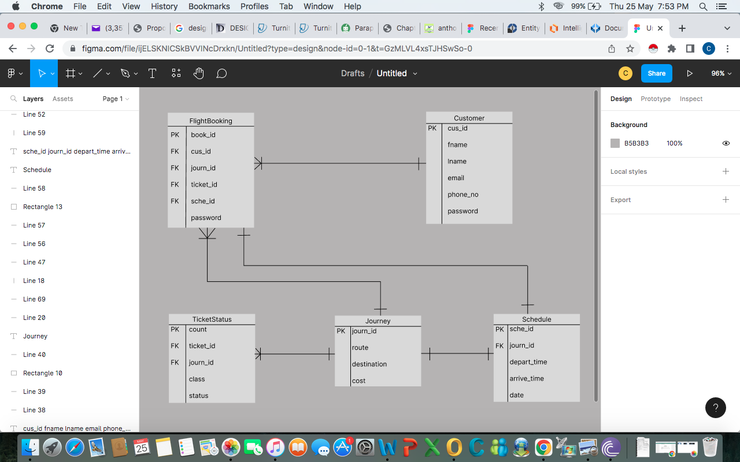

Figure 3.1: *ER Schema*

**3.2.2 Functional Requirement**

For the system's specific applications, the following specifications were noted.

**Checking Availability**

The user must enter the cities they are going from and their place of landing also the date of travel in order to search for flights.

**Reservation of Flight**

The system will ask the user for confirmation after they have entered all the necessary data. Following confirmation of the information provided and payment, the seats are booked.

**Canceling / Rescheduling of Ticket**

To cancel the booking, the user must input the id number of the flight or ticket number.

**View Ticket Status**

Users of the system will be able to access travel information. After entering the reference number, it connects to the database and retrieves the trip details before presenting them to the user in a user-friendly format. In conclusion, the system ought to fulfill all of the goals listed in Chapter One.

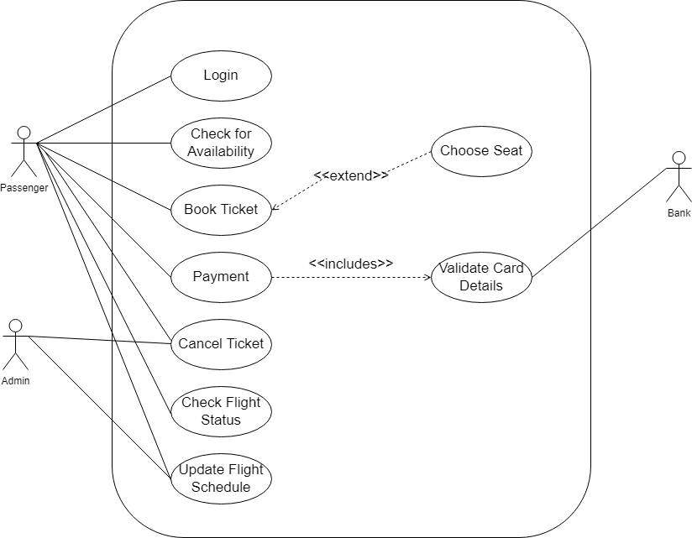

Figure 3.2: *Use Case Diagram*

The individual who uses the system from the perspective of the user

Home page

Login & register

Book flight

Cancel Reservation

Contact Company

Customer or end user

Figure 3.3: *Customer Use Case Diagram*

The individual in charge of updating the system content

Login/Logout

Add/delete/Modify/

Flight Information

View cancelled &

reserved tickets

Administrator

Figure 3.4: *Administrator Use Case Diagram*

**3.2.3 System Architecture**

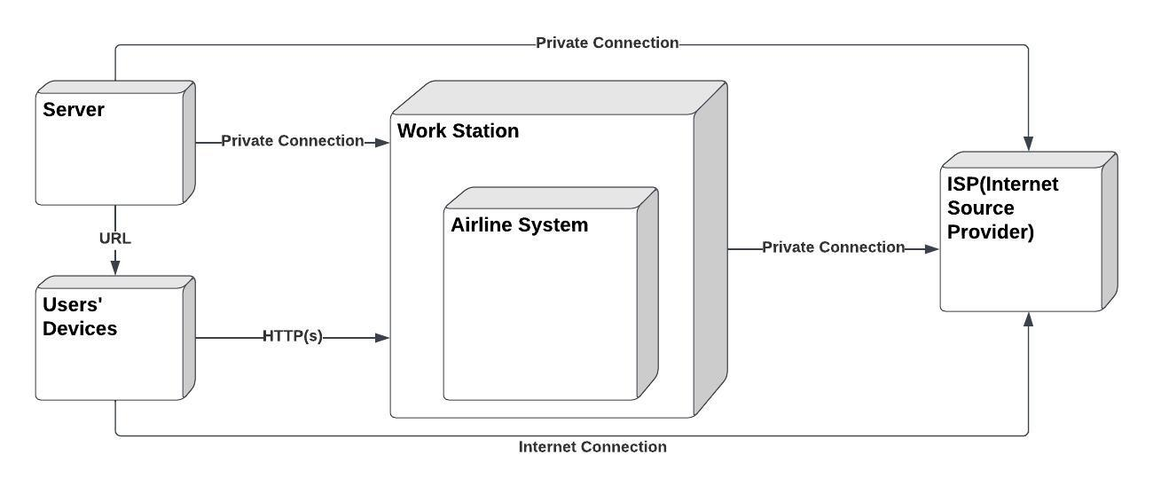Figure 3.5: *Deployment Diagram*

The system scenario is depicted in the deployment diagram. It has 5 nodes, each of which is represented by a box with a relational link. The workstation, user devices, the system, internet source, and server are the nodes. The system includes a number of artifacts (sub-systems), including airline reservation and information.

The server is connected to the workstation through a private connection, allowing it to transfer data to the devices and be accessible by the users. Users can then connect and interact over the internet connection.

**3.2.4 Software Structure**

This diagram classifies the functions and services that each object performs within the system by illustrating the relationships between them.

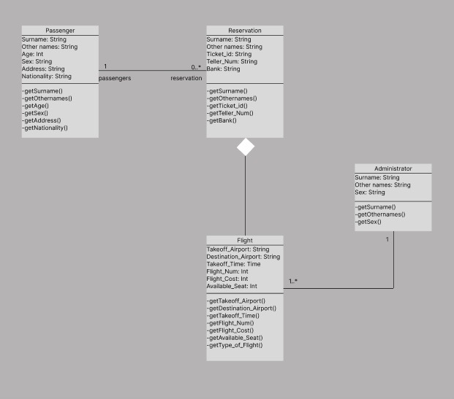

Figure 3.6: *Class Diagram*

**3.2.5 Workflow of Use Cases**

|  |  |
| --- | --- |
| Customer | Reservation System |

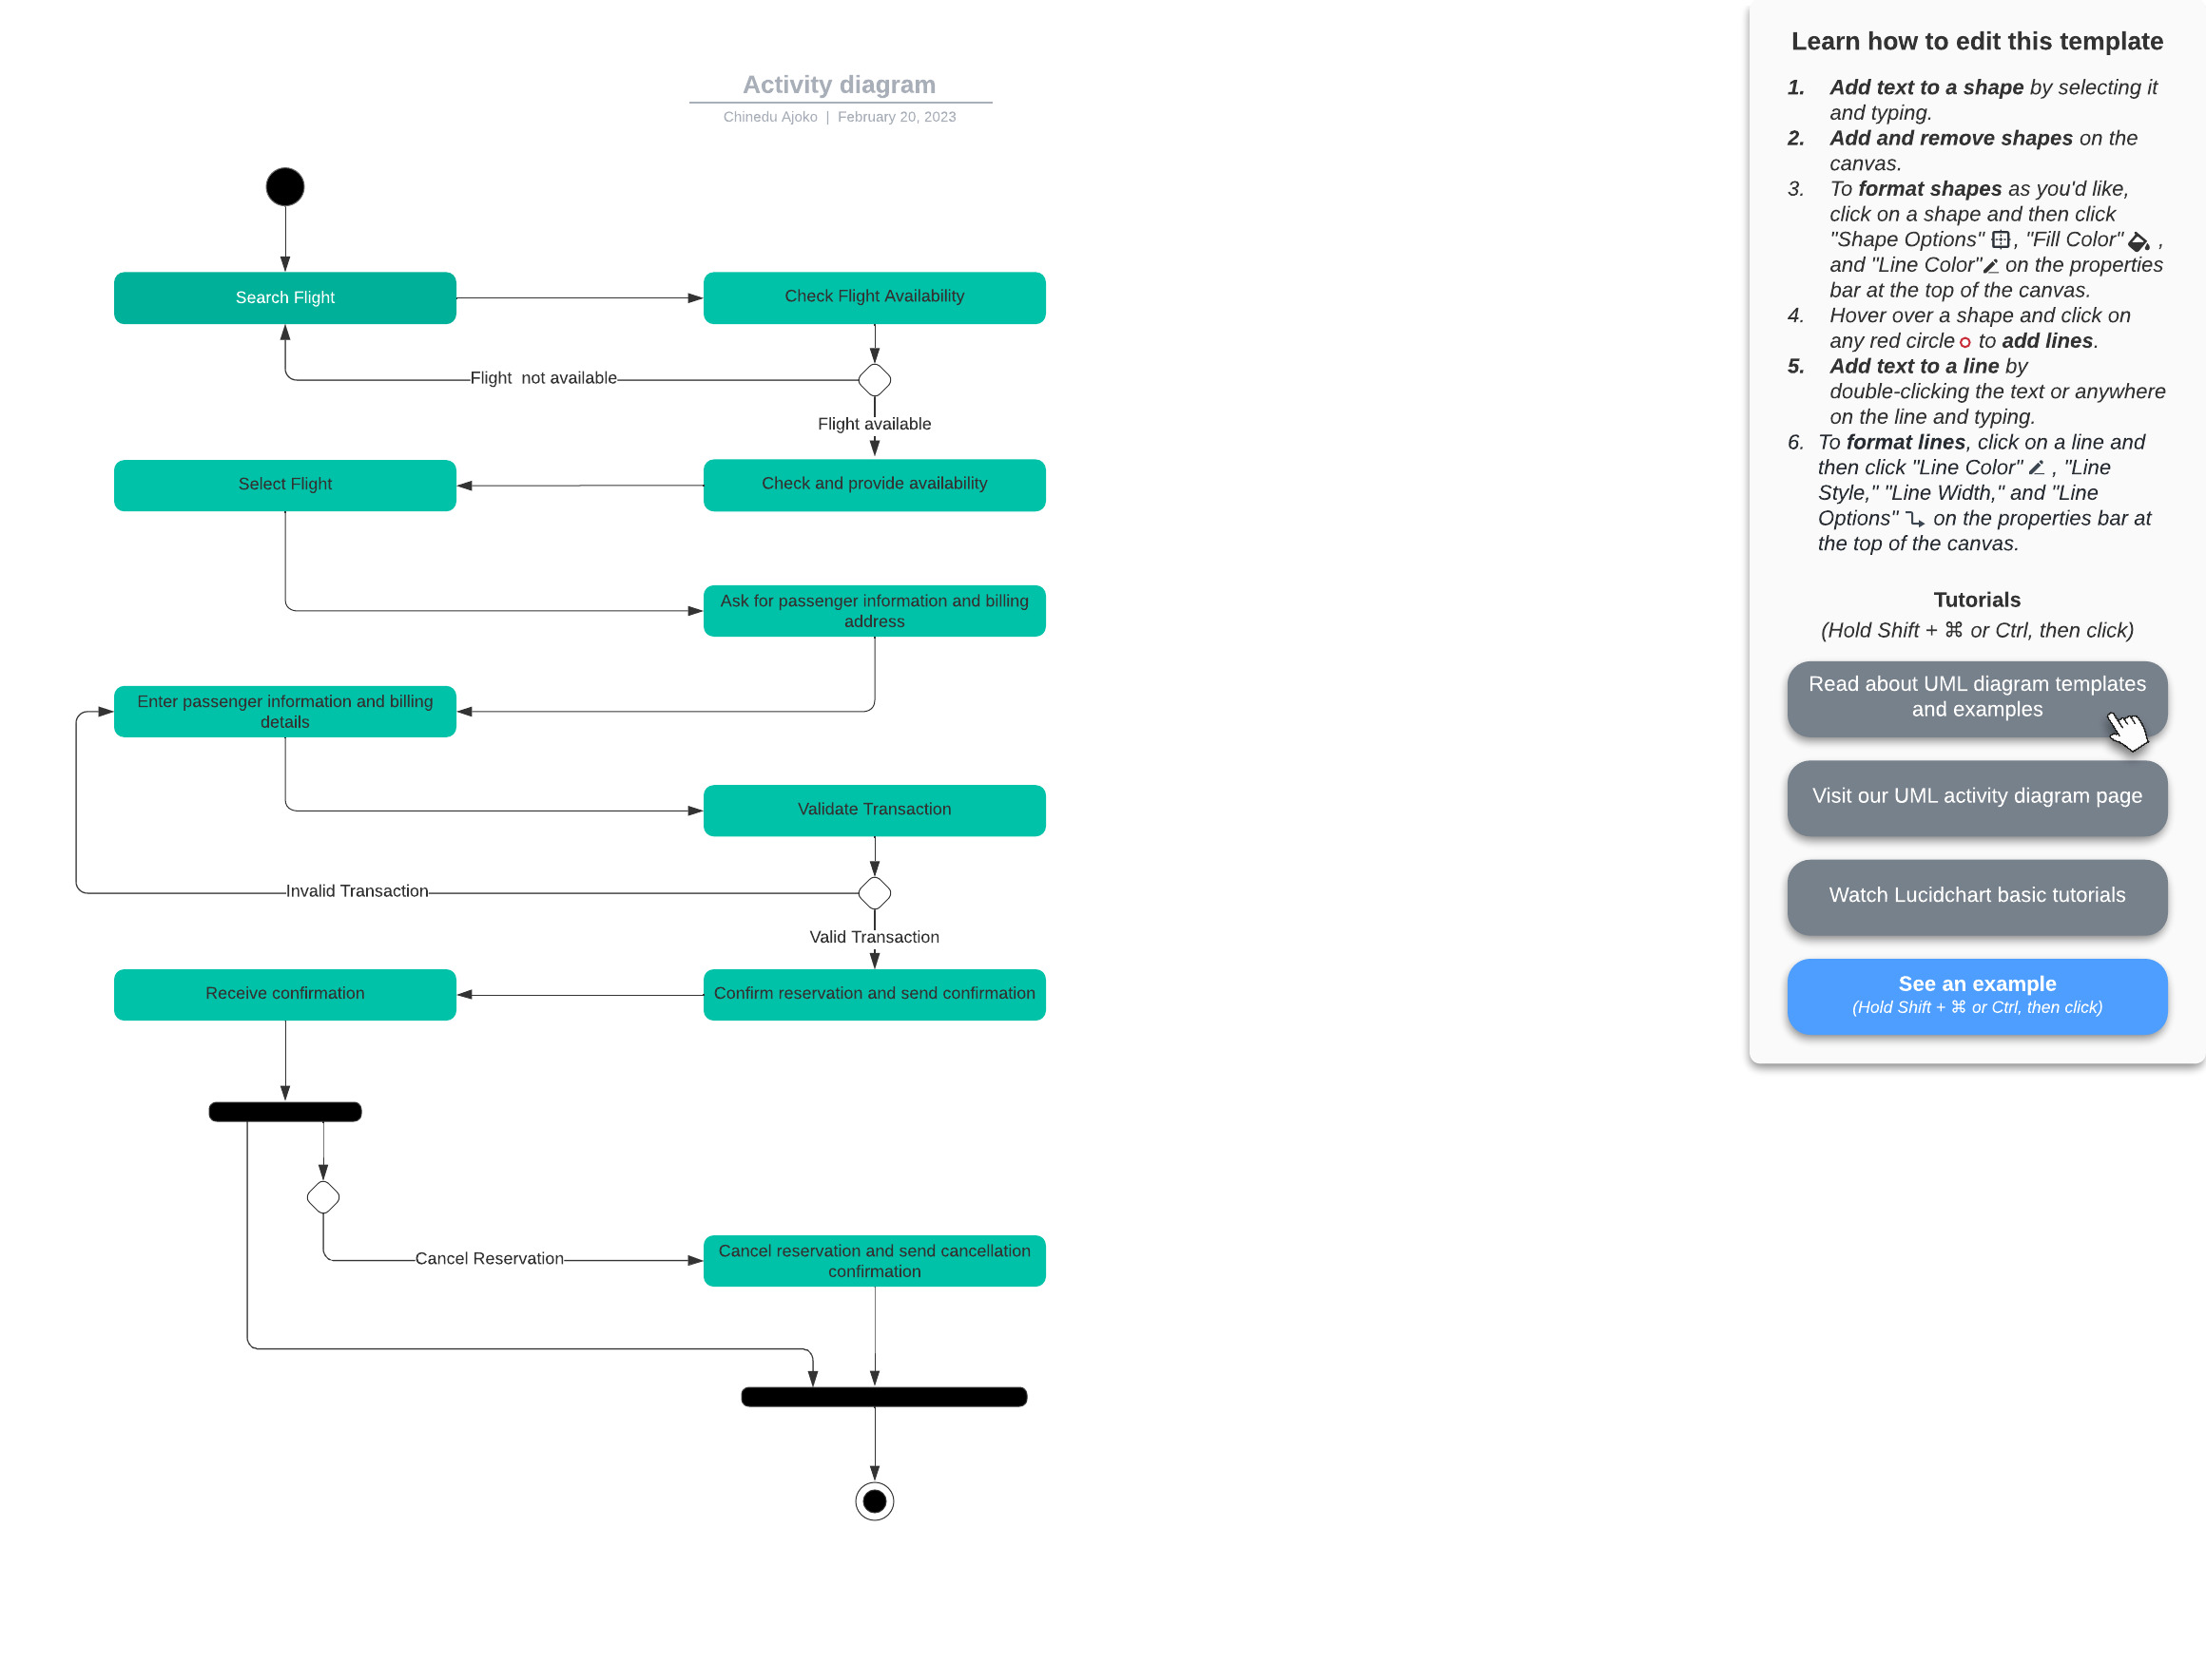

Figure 3.7: *Activity Diagram*

Activity diagrams are a type of behavioral diagram that capture the implementation of system operations as well as business processes and use cases.

The diagram shows the process of how the system is used to book flights. A customer searches for the availability of flights according to the destination, the system checks and gives a result (flight not available or flight available), if flight is available the prices are shown to customer who selects the desired flight, this asks for passenger billing details to process payment. If transaction is validated, customer receives confirmation and process is ended. Another output can be gotten if customer decides to cancel reservation. When this is the case, the system cancels the reservation and ends the process.

**CHAPTER FOUR**

**IMPLEMENTATION AND DISCUSSION**

*This section uses the diagrams as help in implementing the proposed work and turning it into a whole system that is functional.*

**4.1 System Requirement for Development**

The hardware components used: A 64-bit (x64) processors Intel Core i5 CPU at 2.5 GHz personal computer, highly reliable power supply to power up the computer during development. The system is compatible with all Pentium III and later users, as well as Linux, Windows NT, and Mac computers with 512 MB of RAM, at least 10 GB of hard drive space, and a 550 MHZ CPU speed.

The software components used: Microsoft Visual Studio Code and Firebase were both used to develop the system. With Firebase, users can access scalable and fast hosting when creating web applications.

**4.2 System Menus Implementation**

The frontend of the system was implemented with JavaScript on React.

After completing all design and necessary functionality work, the system operates well. I made an effort to illustrate screen shots and a preview of each web page in this chapter.

The interfaces for the user's environment and the administrator's environment differ.

**User’s environment**

**a) Welcome Page**

Any browser will display the welcome page when the Nigeria Air URL is typed in it. This page acts as the company's home page. By clicking "book now" on this page, users may

access other websites and the reservation platform. Users can also sign up and purchase tickets, flights, and other travel-related data after doing so.

There are navigation links at the top of the page that can take you to different website pages, including the sign in, and contact us sites.

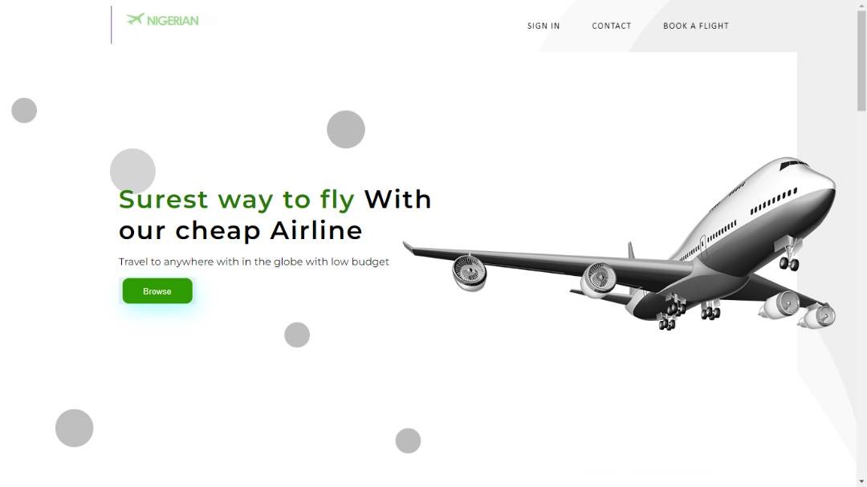

Figure 4.1: *Home Page*

**b)** **About us page**

What prospective consumers need to know about Nigeria Air, including its history, story, purpose, and vision statements, is provided on this page.

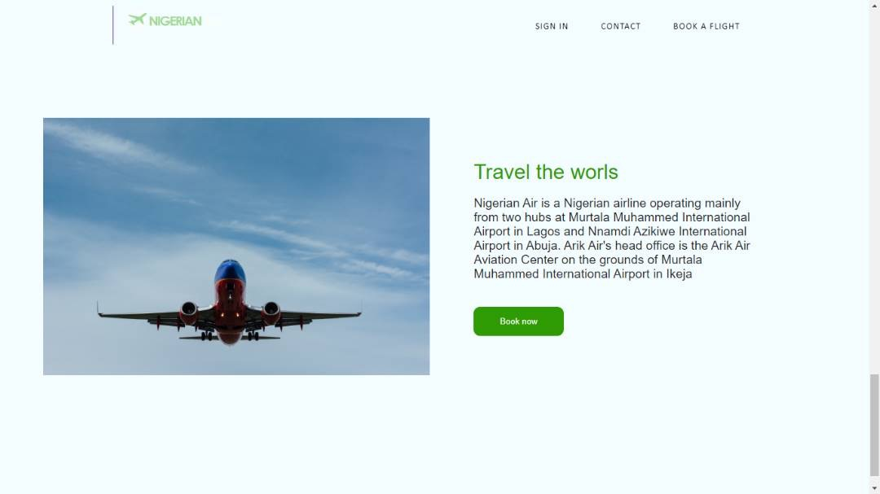

Figure 4.2: *About us page*

**c)** **Registration Form**

Customers (Passengers) register using this form before purchasing a ticket. The purchaser registers by clicking the register link on the home page to go to this page. Prior to adding the record, the customer must fill out the required information, customer id and customer password.

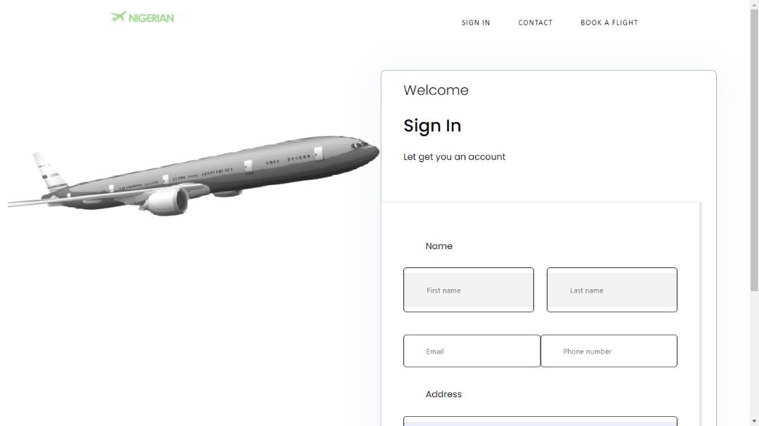

Figure 4.3: *Sign Up page*

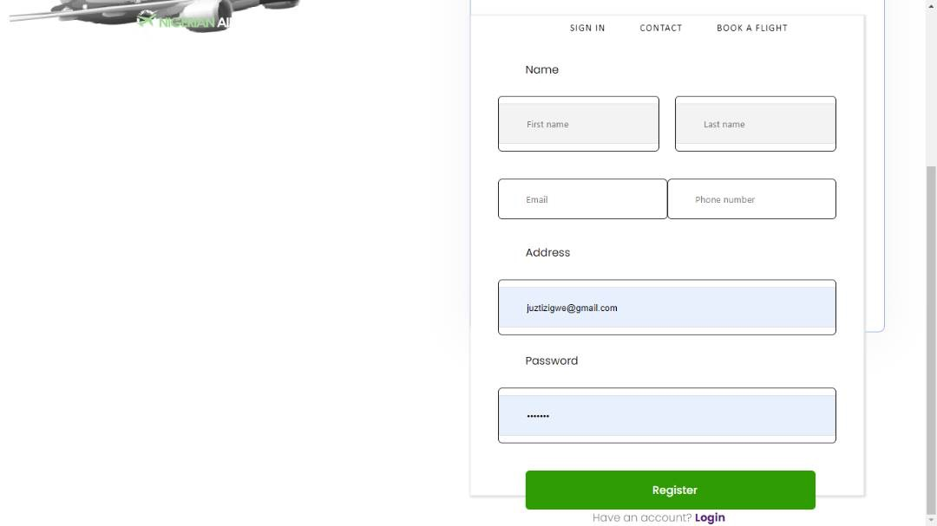

Figure 4.4: *Sign Up page with details inputted*

**d) Login page**

Registered users can access their accounts by entering a valid email address and password on the login page.

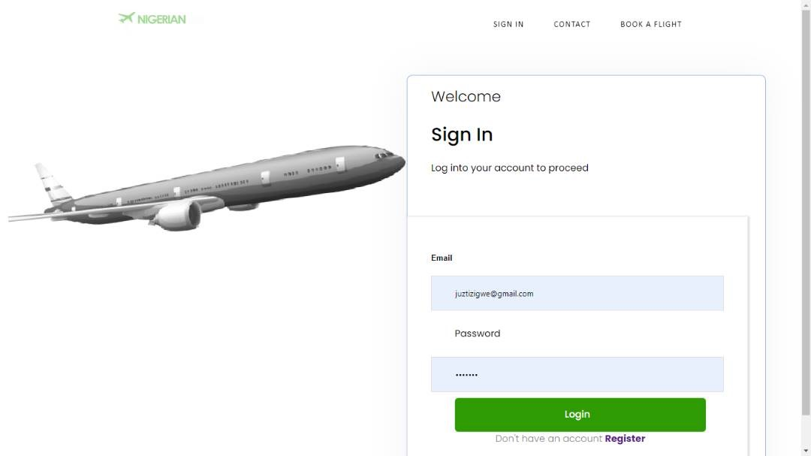

Figure 4.5: *Sign in Page*

**e**) **Payment page**

On this page the payment for the airfare is made as details of a valid bankcard is entered. Card issuer’s country is defaulted as Nigeria.

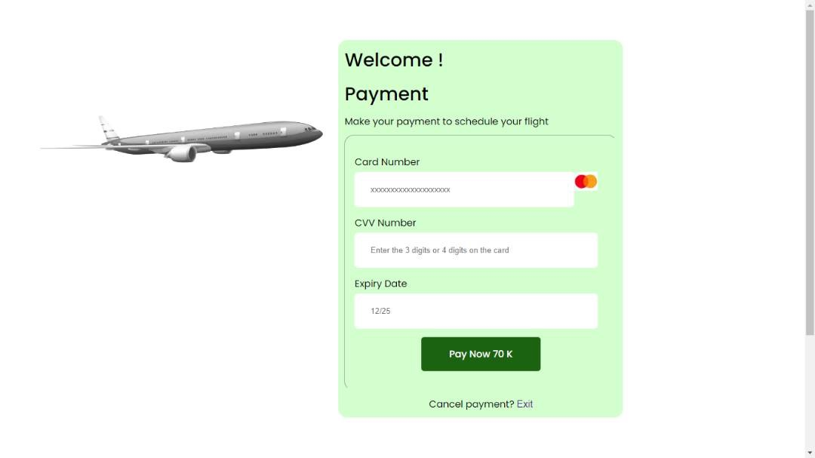

Figure 4.6: *Payment Page*

**f) Flight/Ticket Form**

After logging in, this interface is accessible. This interface is used by users to purchase airline tickets. Reservations can only be made by registered users.

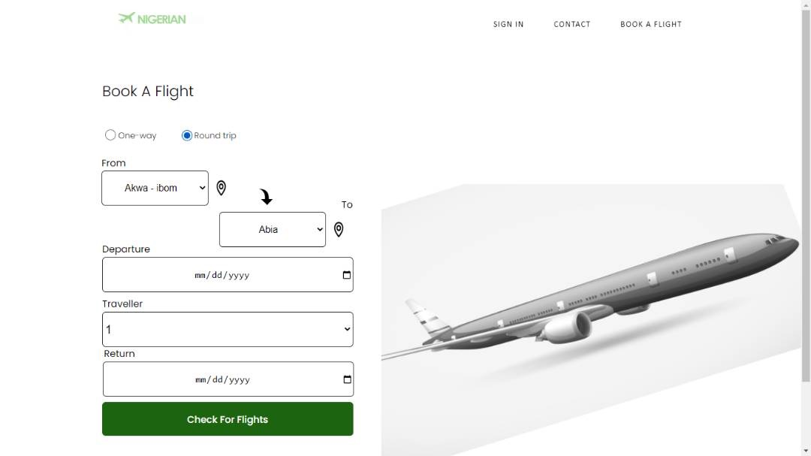

Figure 4.7: *Book a Flight form for Round trip*

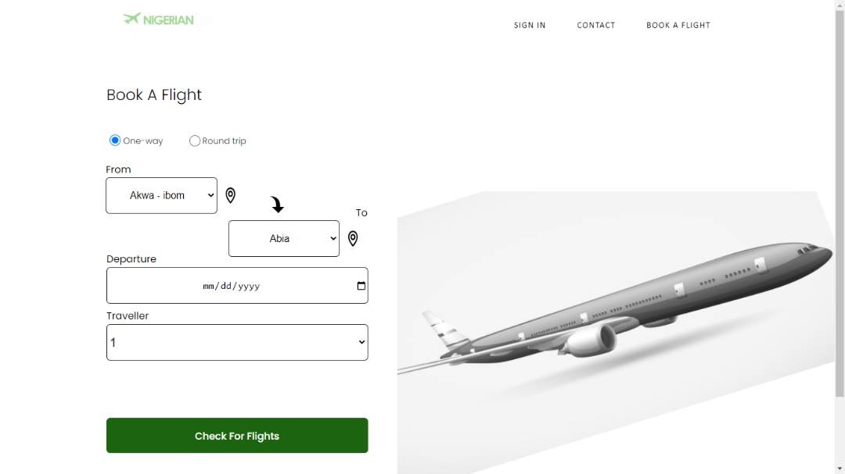

Figure 4.8: *Book a Flight form for One-way trip*

**g) Ticket Detail Interface**

When a ticket is purchased, this interface is displayed. The user should keep the ticket ID since it will be needed when booking a flight.

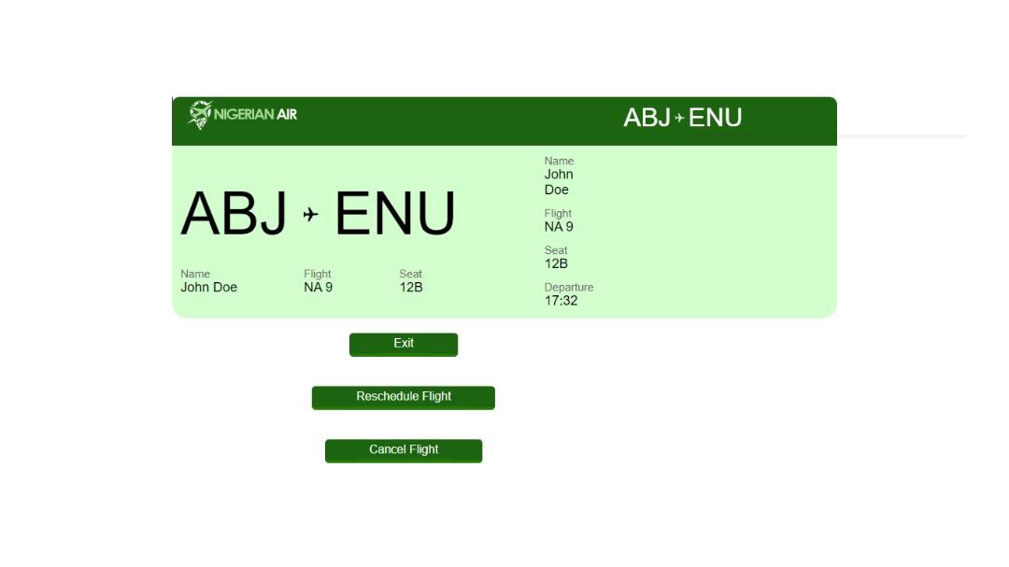

Figure 4.9: *Ticket pass print*

**h)** **Contact us page/Interface** :

Clicking the contact us link in the system menu will access this interface. This page is intended to answer user inquiries. Any user or client, registered or not, may publish anything on this website with which they are dissatisfied.

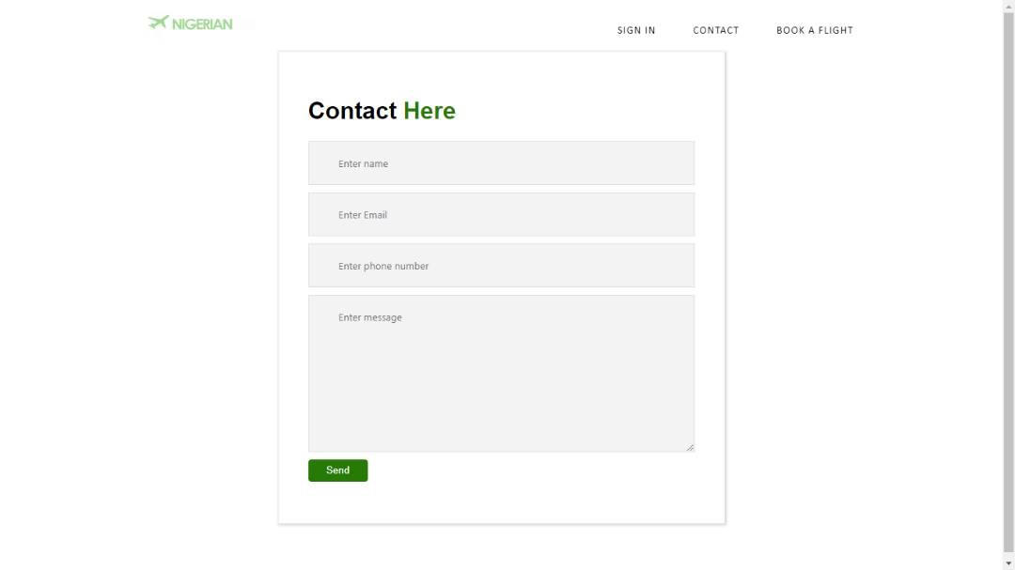

Figure 4.10: *Contact us page*

**Administrator’s environment**

The administrator to control the system uses it. This environment requires an admin password in order to access it. Admin can access the administrator control panel by entering the proper login information. The user has complete authority over the system and the power to update and remove once the proper admin credentials is given.

**i) Administrators Home Interface**

The administrator views this display, which serves as their home page, after entering the correct admin login and password in the dashboard. Through this interface, the admin could initiate reservations, modify flight information, modify journey and schedule specifics, and control the system.

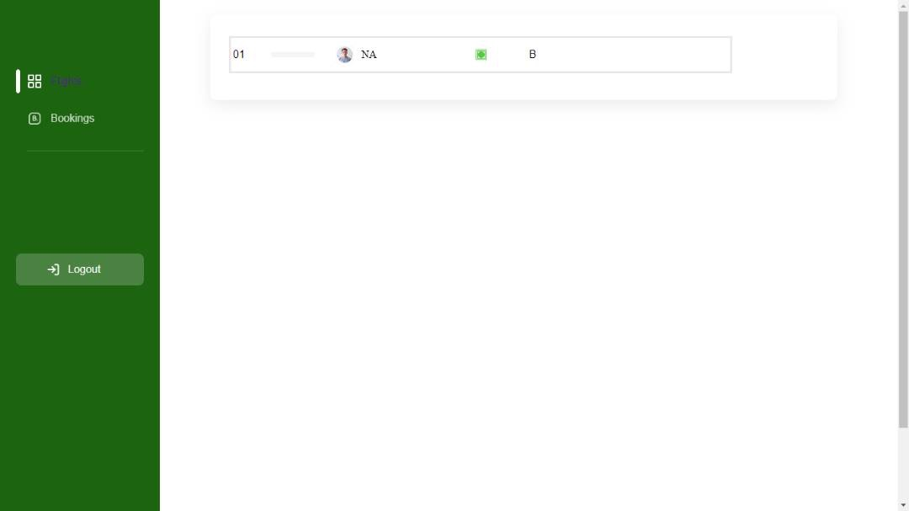

Figure 4.11: *Admin Home Interface*

**j) Add Schedule Interface**

The administrator to add flight schedules to the database uses this interface. Customers can thereafter reserve schedules that are put here. The administrator can edit or add to an existing schedule in this section. Price is also set here.

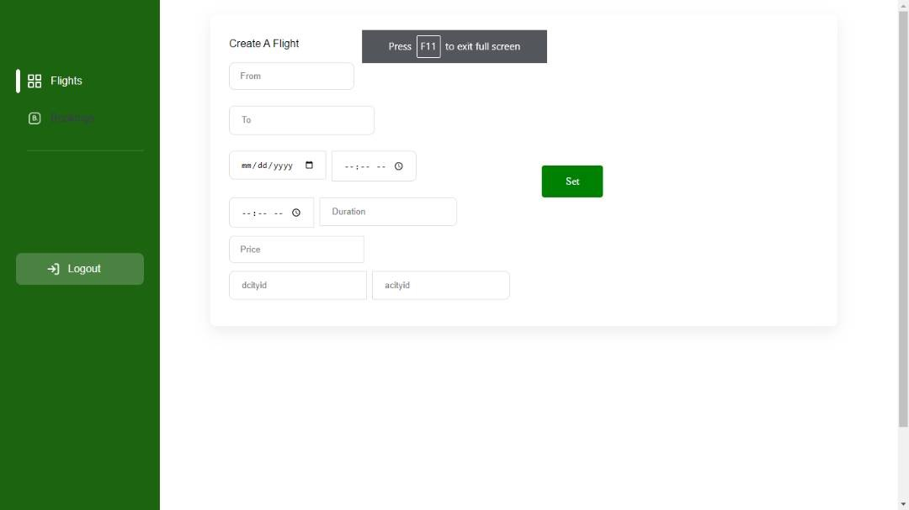

Figure 4.12: *Admin Create Flight Interface*

**4.3 Database Implementation (Backend- description of implementation of the system)**

For my backend connection, I used firebase to implement the backend. It is

easy to use and allows real-time database connection, which makes the

coding process move faster.

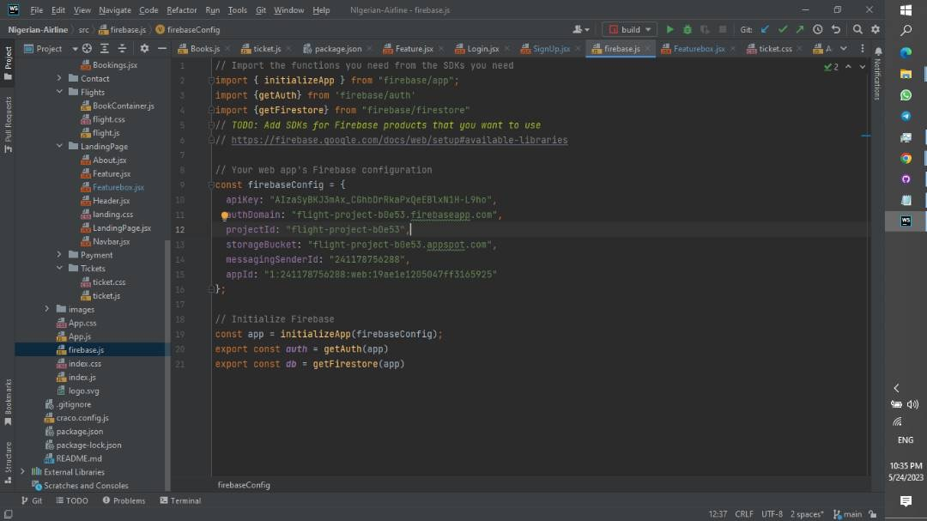

Figure 4.13: *Firebase configuration*

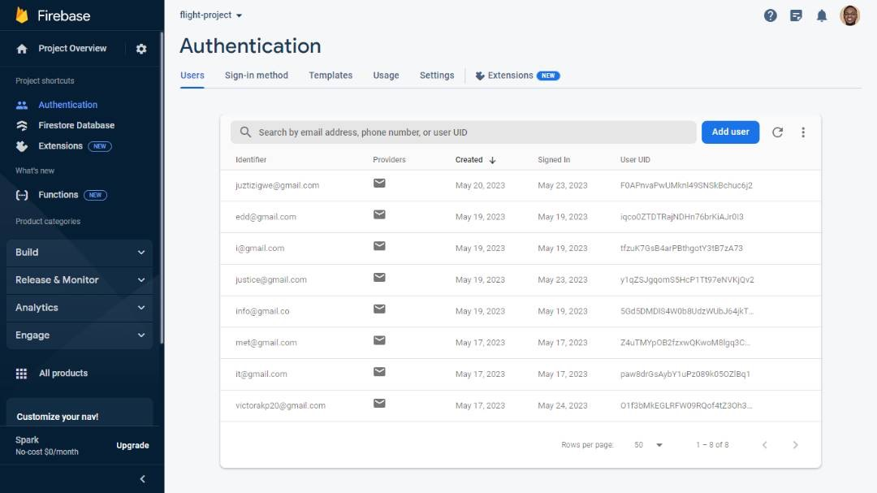

Figure 4.14: *Firebase Backend (Authentication)*

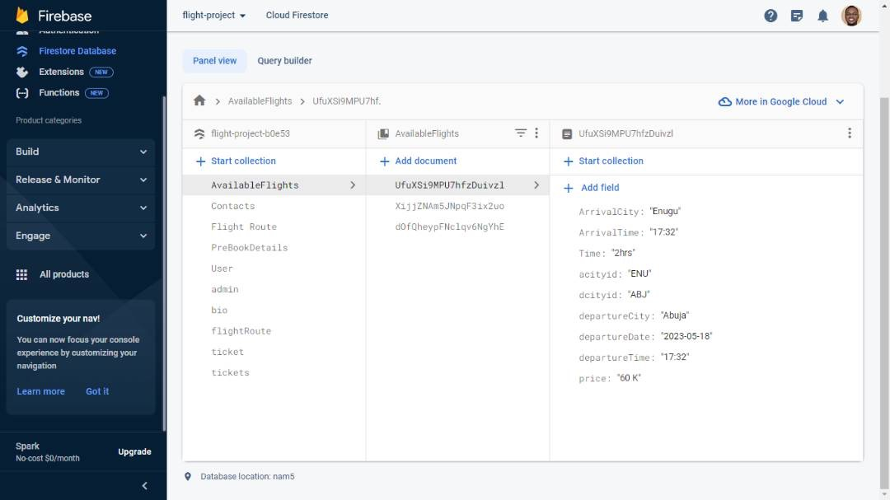

Figure 4.15: *Firebase Backend (Database)*

**4.4 System Testing**

Table 4.1: *Test Run through on system*

|  |  |  |
| --- | --- | --- |
| **Test ID** | **Name** | **Tests Performed** |
| 001 | Registration | The first test was done to register admin into the system from user side using admin login details. |
| 002 |  | Tried registering a user this time but left some fields out intentionally blank. |
| 003 |  | I tried to register a new authorized user to the admin end. |
| 004 |  | Registered User using the correct details on user end. |
| 005 | Login | The first test involves trying to log into the system with an erroneous email address and password. |
| 006 |  | The second test I tried a correct email and wrong password. |
| 007 |  | For third test I did the login again but with the correct password and email. |
| 008 |  | I tried to login to the admin side with unauthorized user detail. |
| 009 | Make a Booking | I tried to book a flight with an already passed date. |
| 010 |  | Tried to book flight but inserting all the necessary information needed. |
| 011 | Create Flight | I tried to make a flight on the admin end by entering the correct details. |
| 012 |  | Tried creating flight and intentionally didn’t fill some parts of the form. |
| 013 | Cancel Booking | I tried cancelling a booking. |
| 014 | Rescheduling | I tried to reschedule a booking. |

**Result of the Test conducted**

Table 4.2: *The result of the Tests*

|  |  |
| --- | --- |
| **Test ID** | **Result** |
| 001 | Failed |
| 002 | Failed |
| 003 | Failed |
| 004 | PASSED |
| 005 | Failed |
| 006 | Failed |
| 007 | PASSED |
| 008 | Failed |
| 009 | Failed |
| 010 | PASSED |
| 011 | PASSED |
| 012 | Failed |
| 013 | PASSED |
| 014 | PASSED |

With this analysis, the system performs as expected as it gives a failed result where it should and a passed result where it should. So the system works as far as the correct and complete information in inputted.

**CHAPTER FIVE**

**CONCLUSION AND RECOMMENDATION**

*The study's successful conclusions, recommendations, and findings are summarized in this chapter for the newly designed system.*

**5.1 Summary of the Study**

In general, project evaluation is a systematic assessment of the value, merit, and importance of the project activity. A brief review of the complete project activity, including the project overview and constraints, is provided below.

**Overview Project:**

It is obvious that new technology is replacing everything and streamlining procedures. It is saving us time and providing us with the finest advantages of the modern age. This project work is a method that can enhance Nigeria Air's ability to book tickets. The purpose of this project is to build Nigeria Air a website that will allow users to book flights online. Before the payment is done, users of this system shall be able to register via the internet, look at tickets and flight schedules, and buy tickets online.

**5.2 Conclusion and Recommendations**

Before the invention of modern computing, reservations for tickets were made by hand and done manually. This implied that a traveler would lose a significant amount of time waiting in line for tickets, which would keep the travellers in discomfort.

Nowadays, passengers frequently obtain discounts and other benefits that give their preferred airline an edge as a result of airline rivalry. These processes for booking airline tickets are automated by online bookings, reducing the amount of time lost and the errors committed during the manual process. It is said that making airline reservations online is expensive and unjustly puts competing airlines at a disadvantage.

According to analysts, online flight reservations are one of the finest technologies in the airline sector, and businesses that are yet to embrace them are losing out. However, as Henry R. Luce famously remarked, "Business, more than any other occupation, is a continual dealing with the future; it is a continual calculation, an instinctive calculation." They may see their disadvantages to be added expenses, maintenance costs, and development costs. Looking ahead, future airline companies should take advantage of the World Wide Web and the Internet to develop effective airline reservation systems.

The project has a good system and concept for online ticket management. Users of Nigeria Air will be able to easily, securely, and conveniently buy their flight tickets online thanks to the system. Although a lack of software knowledge and skills in technology could be a concern for this website.

The following are **recommended** for the system:

* Nigeria Air administrators and employees need to be guided on how to make use of the system so they grasp how the whole system works.
* More research needs to be done in order to fully recognize and solve a few of the system's shortcomings and also connect it to the banks for payment.
* As user needs change, the system has to be upgraded. The system's ability to be adaptable is quite helpful since user needs change over time.

• Users should pick usernames and passwords carefully to prevent system security breaches; they shouldn't use short passwords or the names of their friends or relatives.

**REFERENCES**

Global (2012) [http://www.businessdictionary.com/definition/Global-DistributionSystem-GDS.html](http://www.businessdictionary.com/definition/Global-Distribution-System-GDS.html) accessed on May 26, 2012

Doganis, R. (2001). Airline Business in the 21st Century. In *Routledge eBooks*. https://doi.org/10.4324/9780203991916

P. N. Seth, S. S. Bhat (2002): “An Introduction to Travel and Tourism”, Prentice Hall, London. Protection for Consumers,” Sept. 4, 2008 retrieved on June 6, 2012 from [http://www.ehow.com/about_5122697_airline-reservation-systems.html.](http://www.ehow.com/about_5122697_airline-reservation-systems.html)

Stair, Ralph M. (1996). Principles of Information Systems and Managerial Approach, 2nd ed. Cincinnati, OH: Boyd & Fraser. [Accessed May, 19, 2012].

Wikipedia (2012), <http://en.wikipedia.org/wiki/Computer_reservations_system>accessed on May 26, 2012

Winston, Clifford, (1995) ["The Evolution of the Airline Industry",](http://books.google.com/books?id=jCfkJUL8oV0C&printsec=frontcover) [Brookings Institution Press,](http://www.enotes.com/topic/Brookings_Institution_Press) [ISBN 081575843X.](http://en.wikipedia.org/wiki/Special:BookSources/081575843X) Cf. p.61-62, Computer Reservation Systems

Wikipedia (2018), <https://en.wikipedia.org/wiki/Nigeria_Air>

Rochester, Jack B. (1996). "Tools for Knowledge Workers” Using Computers in Information. Indianapolis, IN: Que Education and Training.

Airline (2014) <http://www.enotes.com/topic/Airline_Reservations_System> retrieved on [23. May](http://www.enotes.com/topic/Airline_Reservations_System%20retrieved%20on%2023.May) 2014.

Onome Amawhe, (2017, February 7) Wakanow will become Africa’s biggest online travel company. Vanguard. <https://www.vanguardngr.com/2017/02/wakanow-will-become-africas-biggest-online-travel-company/>

Masaba N.J (2000). a Project report on Application Package to Manage Students’ Records — Makerere University.

Laudon. K & Laudon J.P (2006). The Registration System National Health Service (NHS) retrieved September 20th, 2010 from http ://www.toefi.etest.net.cnlenlenformation

Steven Alter in his book ‘Information Systems 2nd edition’ and Connolly M, Begg E and Strachan D (2007), Database systems Practical Approach to Design, implementation and management. Published by Addison Wesley Company

Atkinson, B. (2015). How does online check in work? , from <http://www.travelsupermarket.com/blog/how-does-online-check-in-work/>

GazetteLive. (2011). The benefits of booking flights online. from <http://www.gazettelive.co.uk/news/local-news/benefits-booking-flights-online3693877/>

Bilotkack, V. and Rupp, N. (2011). A guide to booking airline tickets online. *Mimeo,*

*University of California, Irvine.*

Johanson, M. (2014). How The Airline Industry Has Evolved in 100 Years of Commercial Air Travel?, from <http://www.ibtimes.com/how-airline-industry-has-evolved-100-years-commercialair-travel-1524238/>

Anuradha Prajapati, Kirti Dhirani, Manisha Agrawal, Nandita Gurwara & Seira Tak (2018). A systematic review on online airline reservation system. 2454-132X <https://www.ijariit.com/manuscripts/v4i3/V4I3-1422.pdf>

### JOURNAL OF AIR TRANSPORT MANAGEMENT VOL 16; NUMBER 6; 2010, 346-349 -- Elsevier Science B.V., Amsterdam. – 2010

**APPENDIX I**

**#Project Gantt Chart:**

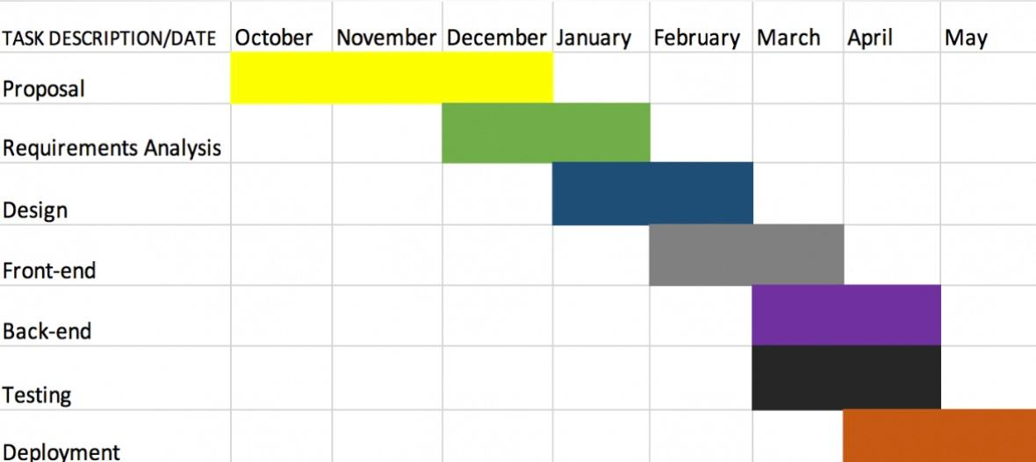

APPENDIX II

#Menu bar code:

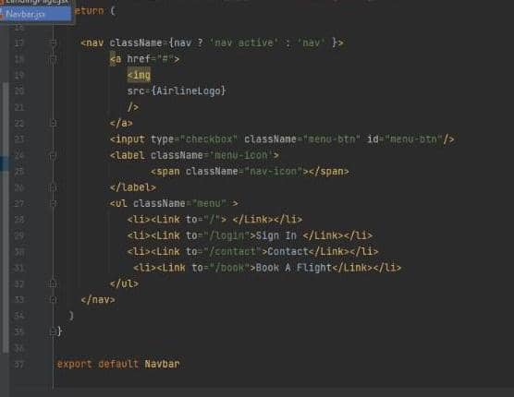

#Pages linking code:

